- You should understand the basic business forms (sole proprietorship, general and limited partnerships, Limited Liability Company, and Corporations.) This information is found in our textbook.

- You should understand what elements are required for a valid contract; this information is found in our textbook.

- You should have read about how some employment practices may not be legal. This information is found in our textbook.

- You should also understand how to do an online search on the Internet.

YOUR NEW BUSINESS

You have been making chocolate chip cookies for your family and friends since your mother-in-law, Delilah Fields, gave you her super-secret chocolate chip cookie recipe 5 years ago. Everyone raves about how good the cookies are. You and your friend(s) think that you can actually start a business selling these cookies to the public.
You have located a commercial kitchen near your home in Lowell, MA, that the public is allowed to use for a nominal fee. You will be able to make the cookies there and meet all health code requirements.
You and your friend(s) want to own the business together, but your friend(s) are surgeons, and own very expensive homes in Massachusetts. You own a vacation home on the lake in New Hampshire, and two expensive automobiles. You and your friend(s) are worried about personal liability if anything ever went wrong. You want to protect these assets from creditors and from law suits. You would prefer to only pay taxes once on your business profits, not twice. You want the income to flow through the business to you and your friend(s). Because the business will be just you and your friend(s), you would prefer not to have to go through all the hassle of holding annual meetings or maintaining a book of minutes from your meetings with each other. You hope that your business will grow, but you don’t have any plans to ever “go public.”
You plan to name your business after your spouse’s mother, who gave you her secret recipe for chocolate chip cookies. You think a good name for your business might be “Mrs. Fields’ Chocolate Chip Cookies.”

INSTRUCTIONS

- Decide which type of business ownership will be best for your Massachusetts business
- Research whether your business name is available and is appropriate to use; if not, choose a new name
- Research the Massachusetts forms that need to be created in order to begin the business in the format that you choose
- Research if any forms need to be filed in Massachusetts, and if they do, where and with whom they should be filed
- Research how much it will cost to file any forms that need to be filed
- Research if any other documents should be created even if they are not required by the jurisdiction you chose

Prepare a one-page paper explaining:

- Why you chose the business form you chose?
- Why you chose the name you chose for your business?
- What forms need to be created?
- What forms need to be filed, if any, where they will be filed, and how much it will cost?
- What other forms need to be created, and why?

RUBRIC

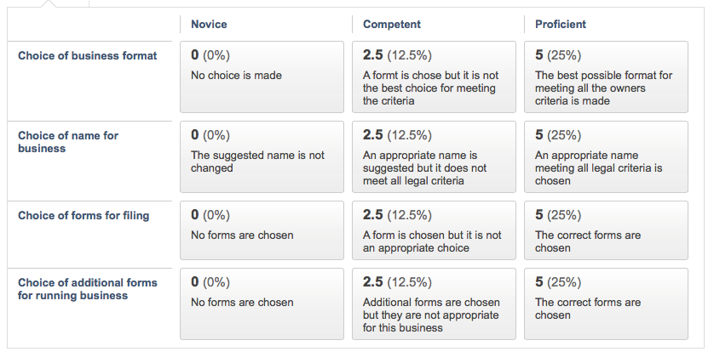

HELPFUL LINKS

- https://www.incorporate.com/business_structure_comparison_chart.html
- http://www.dmlp.org/legal-guide/massachusetts/forming-llc-massachusetts
- https://www.mass.gov/guides/starting-a-new-business
- https://www.nolo.com/legal-encyclopedia/massachusetts-form-llc-31942.html
- https://smallbiztrends.com/2012/03/does-your-business-need-a-dba.html
- https://blackboard.middlesex.mass.edu/bbcswebdav/pid-1721991-dt-content-rid-35369506_1/courses/MERGE.LGL102.30_31.201806.DW/MASTER06.LGL102.DW_ImportedContent_20170523104838/MASTER0901.LGL102.DW_ImportedContent_20160810010208/A%20Comparison%20of%20LLC%20with%20Partnerships.pdf

